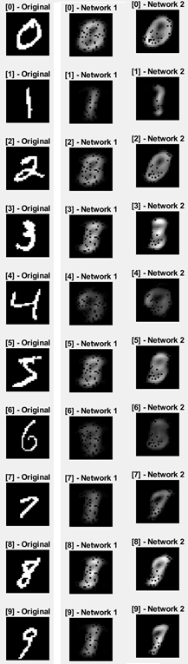Fully connected Autoencoder

Network 1 reproduces about two of them convincingly (0 and 1, the easiest) and Network 2 reproduces about four convincingly (0, 1, 3, and 7).

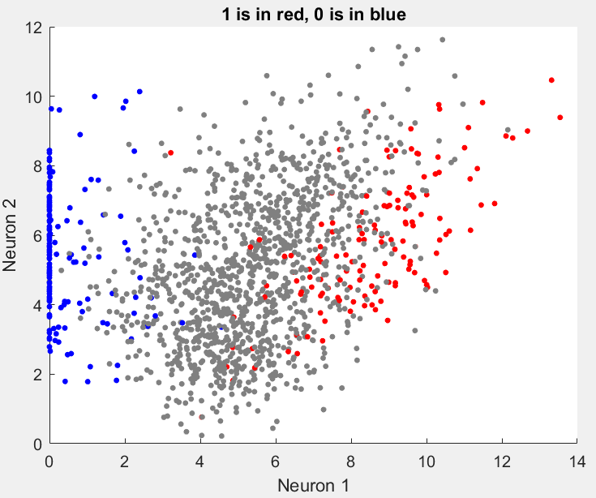Yes! There is a pattern. It separates them linearly. I could use SVM to get a y=mx+b line that discriminates the two.

I chose a few random points from each cluster on the scatter plot and fed them into the decoder. They were all reproduced correctly.

For autoencoder 2, one neuron lights up more for each convincingly reproduced digit. That is to say, one neuron will have a significantly higher value than the others and which neuron that is dictates what the decoder will reproduce. The other digits will have random values with no one neuron dominating.

|  |  |  |  |  |
| --- | --- | --- | --- | --- |
| Digit | Neuron 1 | Neuron 2 | Neuron 3 | Neuron 4 |
| 0 | **22.2246** | 13.4539 | 16.5791 | 9.5972 |
| 1 | 4.7702 | **29.407** | 3.3738 | 2.6155 |
| 3 | 10.6605 | 3.2841 | **19.6941** | 2.6546 |
| 7 | 4.9645 | 5.3134 | 2.9449 | **14.935** |

